**Exp 8: Reproducing an Image Using Prompts for Image Generation**

**Aim:**

To demonstrate the ability of text-to-image generation tools to reproduce an existing image by crafting precise prompts. The goal is to identify key elements within the image and use these details to generate an image as close as possible to the original.

**Procedure:**

1. **Analyze the Given Image:**
   * Examine the image carefully, noting key elements such as:
     + Objects/Subjects (e.g., people, animals, objects)
     + Colors (e.g., dominant hues, contrasts)
     + Textures (e.g., smooth, rough, glossy)
     + Lighting (e.g., bright, dim, shadows)
     + Background (e.g., outdoor, indoor, simple, detailed)
     + Composition (e.g., focal points, perspective)
     + Style (e.g., realistic, artistic, cartoonish)
2. **Create the Basic Prompt:**
   * Write an initial, simple description of the image. For example, if the image shows a landscape, the prompt could be "A serene landscape with mountains and a river."
3. **Refine the Prompt with More Detail:**
   * Add specific details such as colors, mood, and time of day. For example: "A serene landscape during sunset with purple mountains, a calm river reflecting the colors of the sky, and a few trees along the shore."
4. **Identify Style and Artistic Influences:**
   * If the image has a particular style (e.g., impressionist painting, realistic photography, minimalistic), include that in the prompt. For example: "A serene landscape in the style of a watercolor painting with soft, blended colors."
5. **Adjust and Fine-tune:**
   * Refine the prompt further by adding specific instructions about elements like textures, weather conditions, or any other distinctive features in the image. For example: "A serene landscape during sunset with purple mountains, a calm river reflecting the colors of the sky, a few trees along the shore, and soft, pastel tones in the clouds."
6. **Generate the Image:**
   * Use the crafted prompt to generate the image in a text-to-image model (e.g., DALL·E, Stable Diffusion, MidJourney).
7. **Compare the Generated Image with the Original:**
   * Assess how closely the generated image matches the original in terms of colors, composition, subject, and style. Note the differences and refine the prompt if necessary.

**Tools/LLMs for Image Generation:**

* **DALL·E (by OpenAI)**: A text-to-image generation tool capable of creating detailed images from textual prompts.
  + Website: [DALL·E](https://openai.com/dall-e)
* **Stable Diffusion**: An open-source model for generating images from text prompts, known for its flexibility and customizable outputs.
  + Website: [Stable Diffusion](https://stability.ai/)
* **MidJourney**: A popular AI tool for generating visually striking and creative images based on text descriptions.
  + Website: [MidJourney](https://www.midjourney.com)

**Implementation:  
Image 1:**

1. **Examining the given image:**

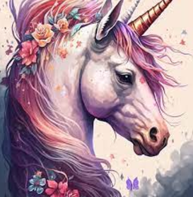

The image appears to depict a colorful unicorn adorned with flowers and a dreamy background.

1. **Basic Prompt:** “*A unicorn adorned with flowers.”*
2. **Refining and adding details:** *“A pink unicorn with a golden horn and adorned with flowers in a dreamy background.”*
3. **Selected Tool:** DALL-E  
   Input Prompt: *“A pink unicorn with a golden horn and adorned with flowers in a dreamy background.”*

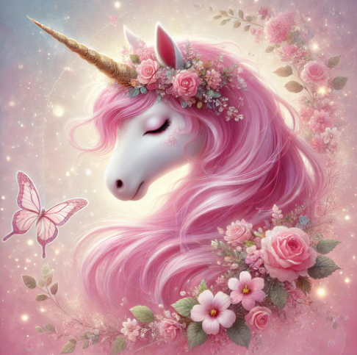

1. **Iterating and adjusting:** “A pink unicorn with a golden horn and adorned with flowers in a dreamy background with a painted art style.”

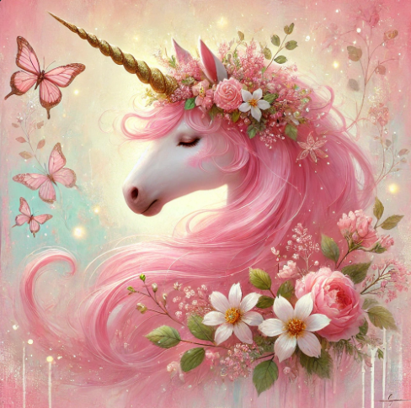

1. **Documenting:** The refined image stays true to the magical and whimsical essence of the original while leaning more towards a painterly art style with heightened vibrancy and detail. It feels warmer, more enchanting, and slightly more fantastical due to the use of glowing effects and textured strokes.

**Image 2:**

1. **Examining the given image:**

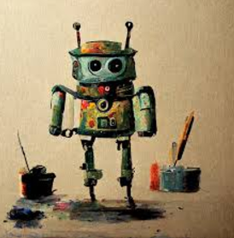

The image depicts a charming, whimsical robot painted in a stylized, artistic manner. The robot is standing upright, painted in vibrant colors with splashes of paint adorning its body.

1. **Basic Prompt:** “*A robot with splashes of pain adorning its body surrounded by artistic tools.”*
2. **Refining and adding details:** *“A small robot with antennas and splashes of pain adorning its body surrounded by artistic tools.”*
3. **Selected Tool:** DALL-E  
   Input Prompt: *“A small robot with antennas and splashes of pain adorning its body surrounded by artistic tools.”*

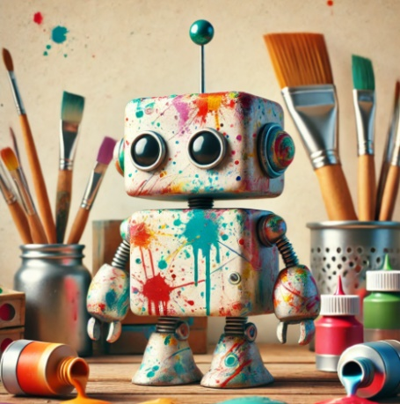

1. **Iterating and adjusting:** “A small robot with antennas and splashes of pain adorning its body surrounded by artistic tools painting on a canvas.”

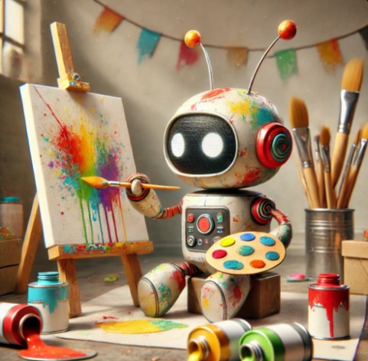

1. **Documenting:** Both the original and refined image highlights the robot's artistic nature, but the refined version adds dynamic storytelling and a more immersive environment.

**Comparison Report (Image 1):**

**Key Similarities:**

* **Focus on the Unicorn:** Both the original and generated images place the unicorn as the central subject, emphasizing its magical and serene nature.
* **Pink Mane and Golden Horn:** The pink mane and shimmering golden horn are consistent across both versions, retaining the magical essence.
* **Floral Adornments:** Both images depict flowers intricately woven into the unicorn's mane, symbolizing grace and fantasy.
* **Dreamy Atmosphere:** Both images feature soft, whimsical backgrounds with floral and glowing elements that enhance the magical tone.

**Key Differences:**

* **Art Style:**
  + Original: A mix of realism and digital illustration with a clean and smooth look.
  + Refined: A painterly art style with visible brushstrokes, adding depth and texture.
* **Color Intensity:**
  + Original: Subdued, pastel-like colors with gentle blending.
  + Refined: More vibrant and saturated, particularly in the pink tones.
* **Details in Background:**
  + Original: Simple and abstract, with minimal butterfly and floral patterns.
  + Refined: Detailed, with glowing effects and richly illustrated floral and butterfly elements.
* **Overall Composition:**
  + Original: Balanced and focused entirely on the unicorn.
  + Refined: Adds additional richness through dynamic lighting and intricate decorations.

**Adjustments Made:**

* Enhanced the focus on the painted art style by emphasizing brushstrokes and textures.
* Increased vibrancy and glow effects in the background for a more enchanting look.
* Highlighted floral and butterfly elements to enrich the dreamy theme.

**Comparison Report (Image 2):**

**Key Similarities**:

* Both images feature a small robot with antennas and splashes of paint adorning its body, representing a playful and creative aesthetic.
* The artistic tools and paint splatters are prominent in both, setting the scene in an art studio-like environment.
* Both images use a neutral background to emphasize the central robot and its artistic theme.

**Key Differences**:

* **Action vs. Static**:
  + *Original*: The robot is static, surrounded by artistic tools but not engaging with them.
  + *Refined*: The robot is actively painting on a canvas, holding a brush and palette, showing creative interaction.
* **Environment Details**:
  + *Original*: Limited details in the environment, mostly focusing on the tools around the robot.
  + *Refined*: More immersive, featuring an easel, canvas, palette, and paint splashes in action, creating a livelier scene.
* **Storytelling**:
  + *Original*: Suggests creativity but lacks an active narrative.
  + *Refined*: Includes a narrative where the robot is caught in the act of creation, adding depth and engagement.

**Adjustments Made**:

* Added terms like "actively painting" and "mid-action" to bring dynamism to the scene.
* Specified additional objects like an easel and a palette to enrich the environment.
* Focused on making the robot the center of an engaging activity rather than a passive figure.

**Conclusion:**

By using detailed and well-crafted prompts, text-to-image generation models can be effective in reproducing an image closely. The quality of the generated image depends on how accurately the prompt describes the image's key elements. The experiment demonstrates the importance of prompt refinement and iteration when working with AI tools to achieve desired outcomes. With practice, the model can generate images that closely match real-world visuals, which is useful for creative and practical applications.